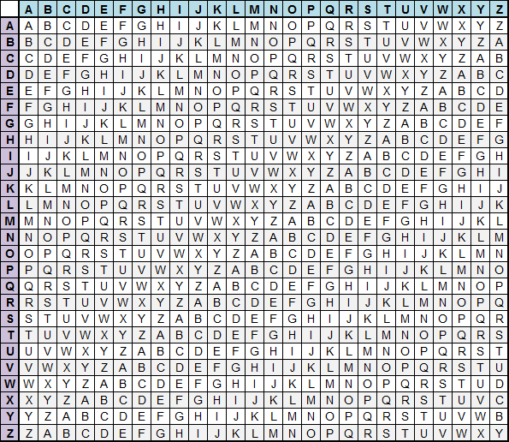
- Decipher the following ciphertext using the Vigenere method with codeword BERTRAND:
NEKAV MNWJG JBJOA OZXYX RRGRG WRRZN TWIIJ TDEGK JRXBE DVIGI IXETJ RSHJ

- The following was enciphered using the Vigenere with a codeword of length 4. Hint: the third letter in the codeword is A.
Laekjhusdxwzlaielxgvjlijlaakoxhrnxeosfiewwoedrtywoeiqlmrde oewlMrquerdetywxxtamieyltlxyhrhieekttiwtlcquixfnmswksffxsnw vaelxvvfuexagtflaiectbfmmiesgymwkyuwyieamensr.
- The following was enciphered using a Vigenere cipher. The length of the codeword is unknown. Hint the word “something” occurs twice in the plaintext. Determine the codeword and decipher:
RLWRV MRLAQ EDUEQ QWGKI LFMFE XZYXA QXGJH FMXKM QWRLA LKLFE LGWCL SOLMX RLWPI OCVWL SKNIS IMFES JUVAR MFEXZ CVWUS MJHTC RGRVM RLSZS MREFW XZGRY RLWPI OMYDB SFJCT CAZYX AQ

