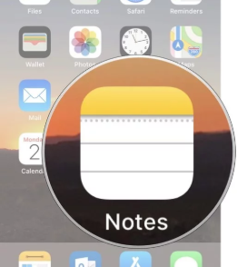
How to scan documents on your iPhone, iPad, or iPod touch using the Notes app
With Notes, you can scan documents and add a signature or manually sign a document on your iPhone, iPad, or iPod touch.

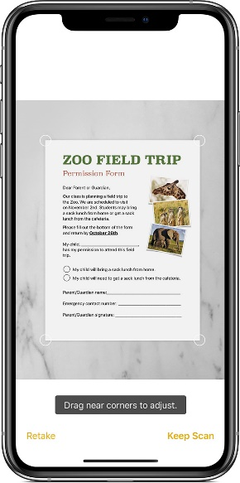

Scan a document
- Open a note or create a new note.
- Tap , then tap Scan Documents.
- Place your document in view of the camera on your device.
- If your device is in Auto mode, your document will be automatically scanned. If you need to manually capture a scan, tap or one of the Volume buttons.
- Drag the corners to adjust the scan to fit the page, then tap Keep Scan.
- You can add additional scans to the document or tap Save when you're done.

Sign a document

- Tap the document in the note.
- Tap , then tap Markup.
- To add your signature, tap , then tap Signature . To manually sign your document, select a tool to use, then sign with your finger or an Apple Pencil with a compatible iPad.
- Tap Done.
