FWRPLOG FAST FIS

FWRPLOG – P Card Departmental Log Report

Objective: To use this report and reconcile all transactions listed on the FWRPLOG report to your montly US Bank statement.

Type FWRPLOG in the Search box, press [Enter].

The Process Submissions Control Scree will appear, click on [Go].

The Pcard Departmental Log Report Screen will appear, enter the following parameters:

Printer Control Block
Printer – enter your printer name (printer begins with WOU_XXX)

Parameter Values Block
Parameters: enter data in the Values column
01 Card number (last 6 digits of card)
02 From date Statement begin date, use date format DD-MON-YYYY
03 To Date Statement end date, use date format DD-MON-YYYY

Submission Block
1. Press Page down to go to Submission block
2. Click Save Parameter Set as – optional, click this box if you want Banner to save the values entered in the
Parameter Values block
3. Click the submit button in the Submission block
4. Click the save icon
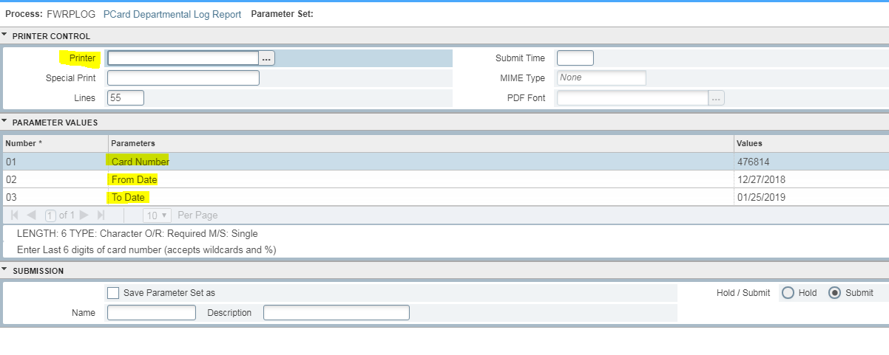
Enter your department printer name

Enter the last six digits of your Pcard
Enter the start date of your US Bank Statement

Enter the ending statement date found on your US Bank Statement

Click on the save button located on the bottom right hand corner.

The report should now print.

