There is a need for trained professionals to work in numerous fields related to gerontology, elder care services, and geriatric medicine. Oregon and the nation’s population are undergoing a dramatic increase in the percentage of older adults.

According to data compiled by the Administration on Aging, by the year 2030 there will be approximately 70 million Americans age 65 and over, up from 40 million in 2010. The U.S. Census Bureau estimated that Oregon’s older adult population is increasing at a rate of 3.5% as compared to the national median of 2.6%.
In addition to the growing older population that will require specialized services, there are also unmet work force training needs. According to the U.S. Department of Labor, employment in home health care services are expected to increase 69.5% between 2004 and 2014, during the same time period, community care services for the older adults are expected to see a 54.8% increase in the need for qualified employees. People from a broad range of career fields who have received training in gerontology will be marketable and provide important services for our community.
An integral component of the gerontology program is a practicum program, which will allow students to get real-world experience through two required practicum experiences. As recent Gerontology alumni have attested, the practicum experience helps students navigate the transition from college to the workforce.
References
1www.aoa.gov/AoARoot/Aging_Statistics/Profile/…/2002profile.doc
2www.census.gov/Press-Release/www/release/CB04-36TABLE4.xls

The Gerontology program prepares students to work in fields that interface with older adults. As the name implies, the major will include coursework in the interdisciplinary field of gerontology. The major reflects a degree of flexibility allowing students to customize a program that not only provides a solid foundation in gerontology, but also allows for course choices that will assist them in preparing for a specific career or future post-graduate education.

Upon completion of the program, the student will be able to:

1. Identify the needs of older adults and assess alternatives to address those needs.
2. Explain the cognitive, physical, and social changes associated with older adulthood.
3. Apply perspectives from two or more disciplines to understanding the needs of older adults.

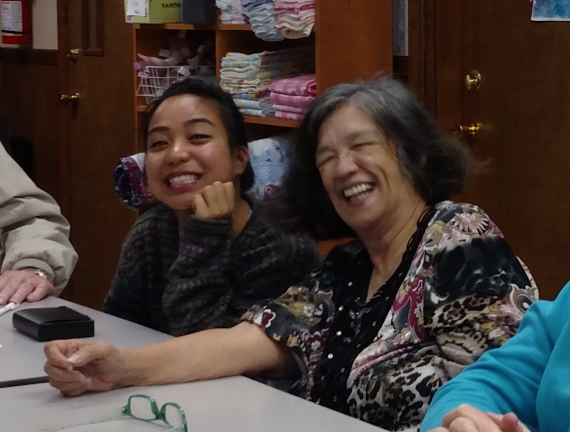

Gerontology Advisors

Dr. Margaret Manoogian manoogim@wou.edu
Gerontology Department Head/Advisor
503-751-4201

Dr. Melissa Cannon cannonm@wou.edu
Gerontology Advisor
503-838-8512

GERONTOLOGY
MAJOR

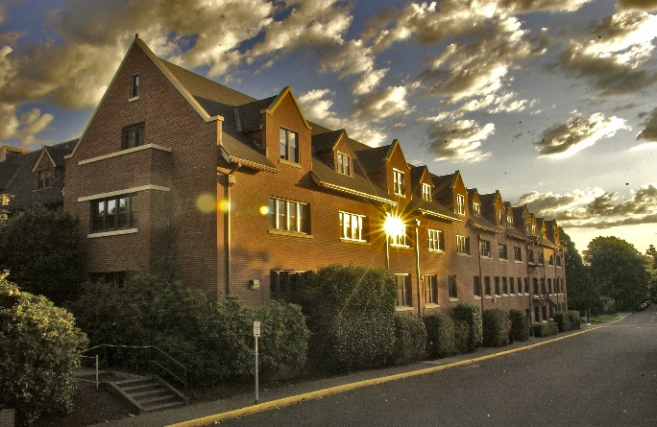

Todd Hall

wou.edu/gerontology

BA/BS Degree in Gerontology

Required Courses 42 hours
PSY 201 | General Psychology I | 4
PSY 202 | General Psychology II | 4
PSY 301W | Introduction to Research Methods | 4
GERO 320 | Introduction to Gerontology | 4
GERO 360D | Cognitive & Physical Changes in Aging | 4
GERO  410W | Practicum I | 4
GERO  411 | Practicum II | 6
GERO 430D | Palliative Care & Chronic Illness | 4
GERO  455 | Social Ties & Aging | 4
GERO 460 | Retirement/LTC Housing for the Elderly | 4

Elective Courses 16 hours
Elective Portion A
(select at least two courses)

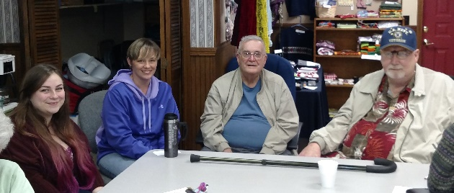

GERO 370 | Aging & Mental Health | 4
GERO 407 | Seminar | 4
GERO 480 | Alzheimer’s Disease & Other Dementias Management | 4
Elective Portion B
(select at least two courses)

PSY 311 | Developmental Psychology | 4
PSY 423 | Interviewing & Appraisal | 4
PSY 439 | Positive Psychology | 4
PSY 445 | Introduction to Industrial Organizational Psychology | 4
PSY 446 | The Psychology of Leadership | 4
PSY 451 | Behavioral Neuroscience | 4
PSY460 | Cognitive Neuroscience | 4
PSY 461 | Psychopharmacology | 4
PSY 483 | Adulthood & Aging | 4
PSY 484 | Death, Dying & Grief | 4
ANTH 395 | Medical Anthropology | 4
BA 211 | Financial Accounting | 4
BA 310 | Principles of Marketing | 3
BA 391 | Human Resource Mgmt. | 3
HE 227 | Community & Public Health | 4
HE 325 | Nutrition | 4
HE 375 | Epidemiology | 4
HE 411 | Health Communication | 4
HE 434W | Diseases | 4
HE 485W | Bioethics & Public Health | 4
HST 484 | Health, Medicine & Gender in Historical Perspective | 4
PS 350 | Introduction to Public Policy | 3
PS 430 | The Aging Society | 3
PS 433 | Healthcare Politics & Policy | 3

Course of Study
The Gerontology major should be planned with a gerontology advisor. The Gerontology major consists of 58 hours of focused coursework beyond introductory coursework. There are no hidden pre-requisites in the required coursework.

The following are examples of some of the numerous employment opportunities in the following fields that would be beneficial to someone trained in gerontology:

- Long Term Care Administration
- Skilled Nursing Care Administration
- Senior Center Operations & Management
- Adult Protective Services
- Occupational Therapy
- Home Health Care
- Physical Therapy
- Speech Language Pathologists
- Teaching
- Nursing
- Recreational Therapists
- Social Work
- Research that Focuses on Older Adults’ Needs and Interests
- Social Services
- Senior Care Services
- Hospice
- Public Policy & Advocate Work for Older Adults

